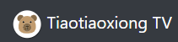

Hello everyone, this is Hongkai with my partner Chengkai. This is team no. 11, we are working on the project Tiaotiaoxiong TV.

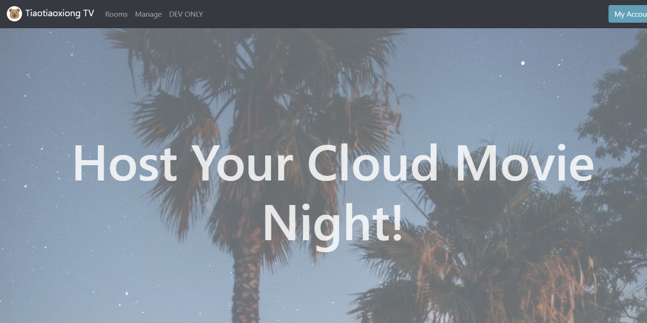

Tiaotiaoxiong TV is a web application that wants to provide people the scenario of watching movies together online. We want to help families and friends to still enjoy the entertainments when they are getting together, even if they are separated by distance.

We want to serve users with a fast, immersive and relaxing experience.

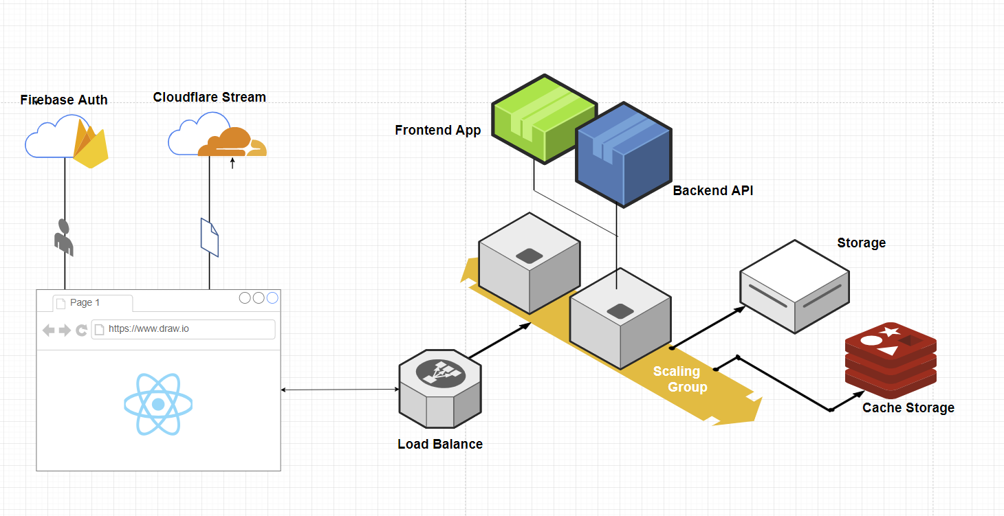

To achieve this, my partner and I started with meticulous planning and system design. We really want our application to have the scalability and potential to run in the more serious real life environment. We are sticking with this structure during our current development, and if time permits we will deploy the application on a cloud platform like Amazon on the final release.

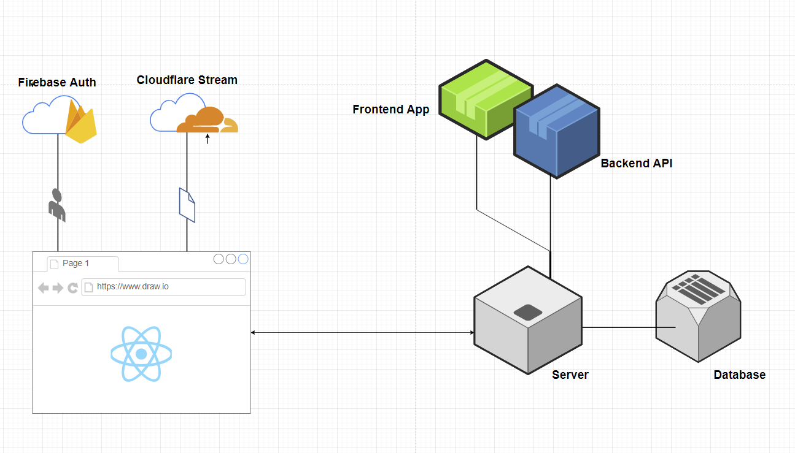

For this prototype review, we want to focus only on the application itself, this will only run in a single server without any scaling and cache storage.

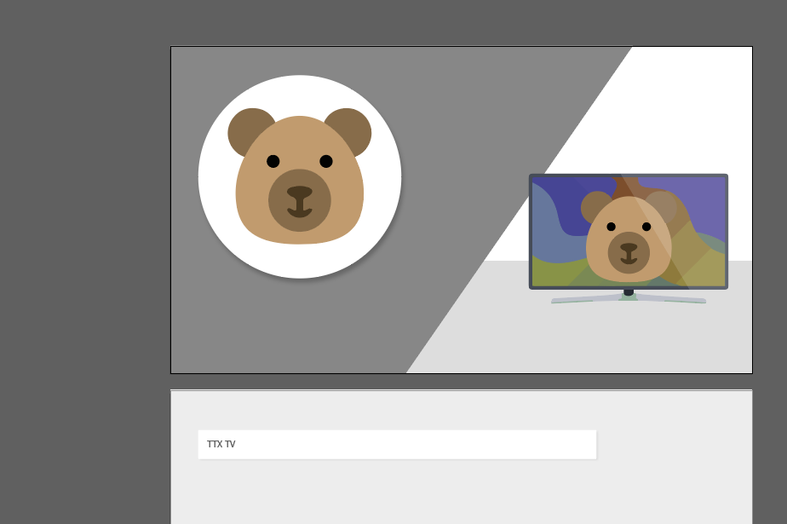

Our team considers UI and UX are the first factors to deliver a good experience, We put in some thinking to design our brand and stylings.

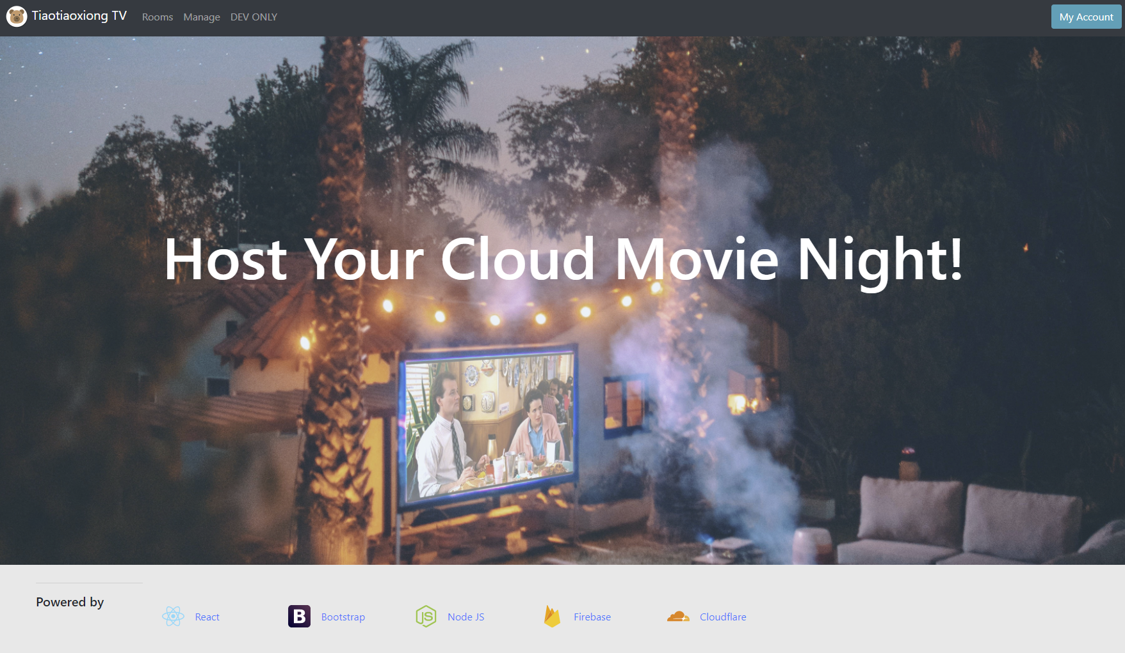

We drafted a frontend design, and built the skeleton of interface using react js.

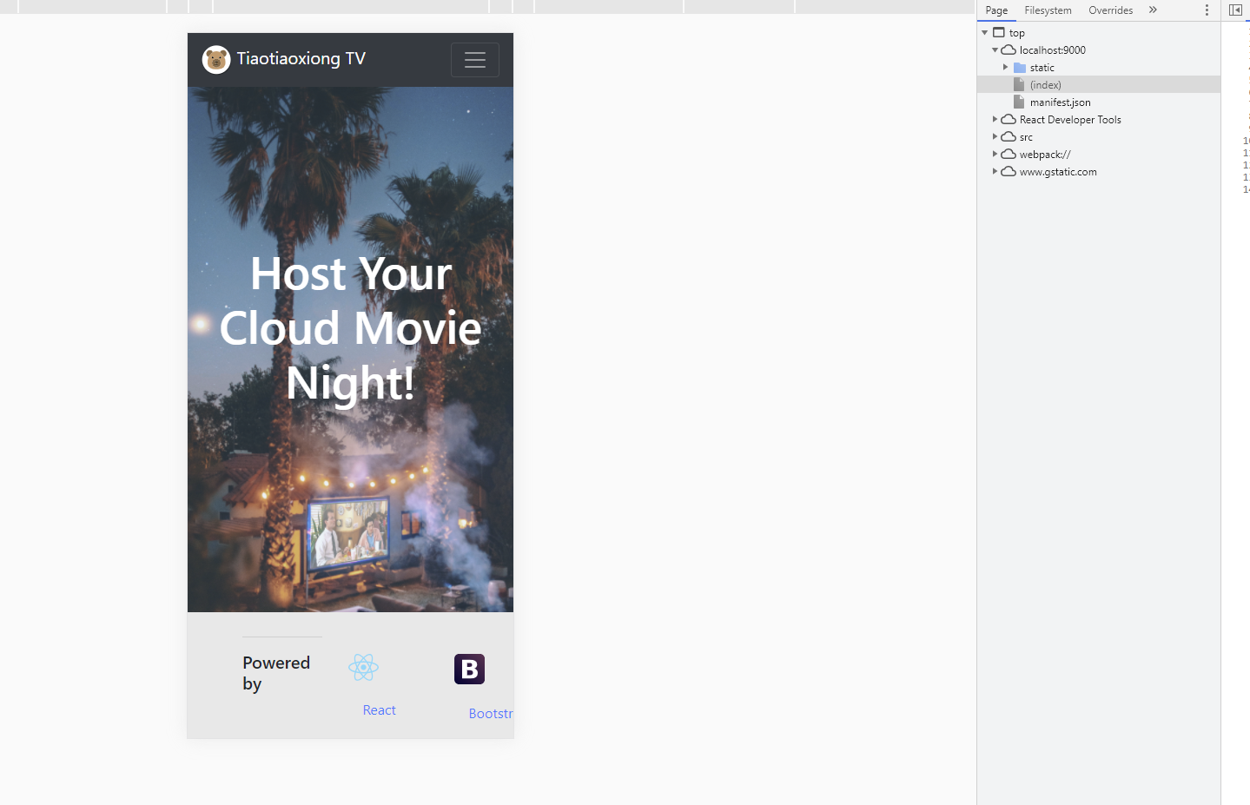

With bootstrap 4 implemented, this app can adapt to all sizes of screens, which we hope would bring users some convenience

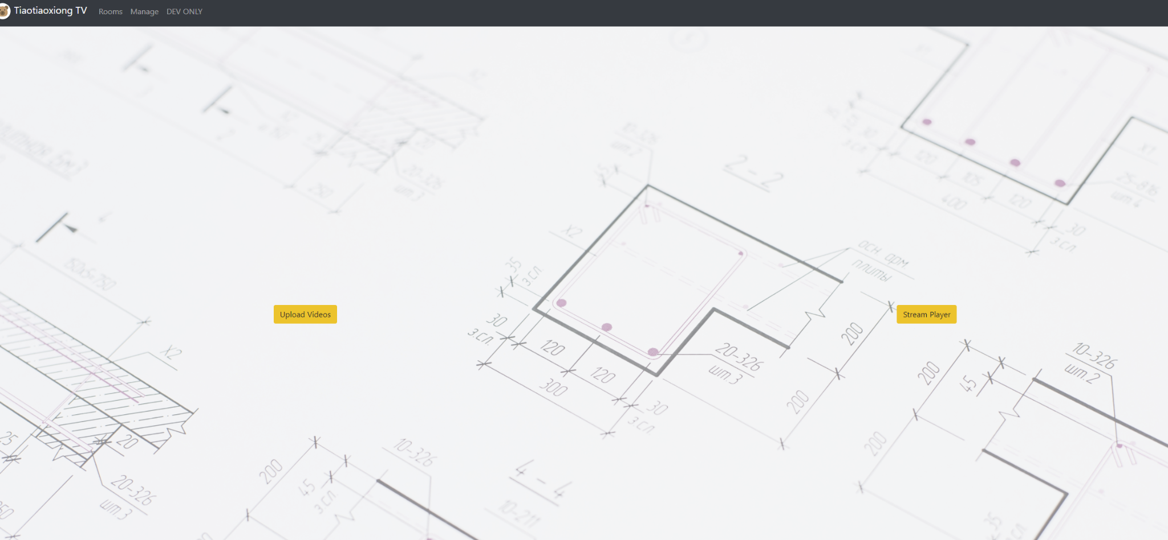

Using this skeleton, we started functional development of our core frontend component, the media stream player. We first started with looking for some stream libraries and apis, our team decided to use the Cloudflare stream as our stream media service .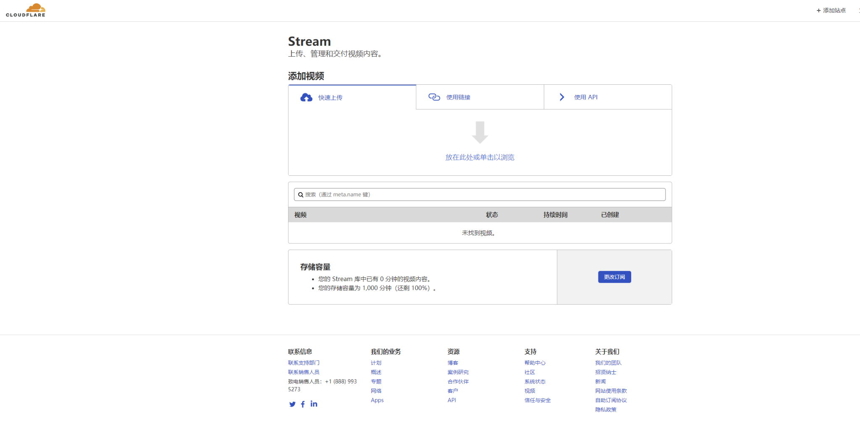

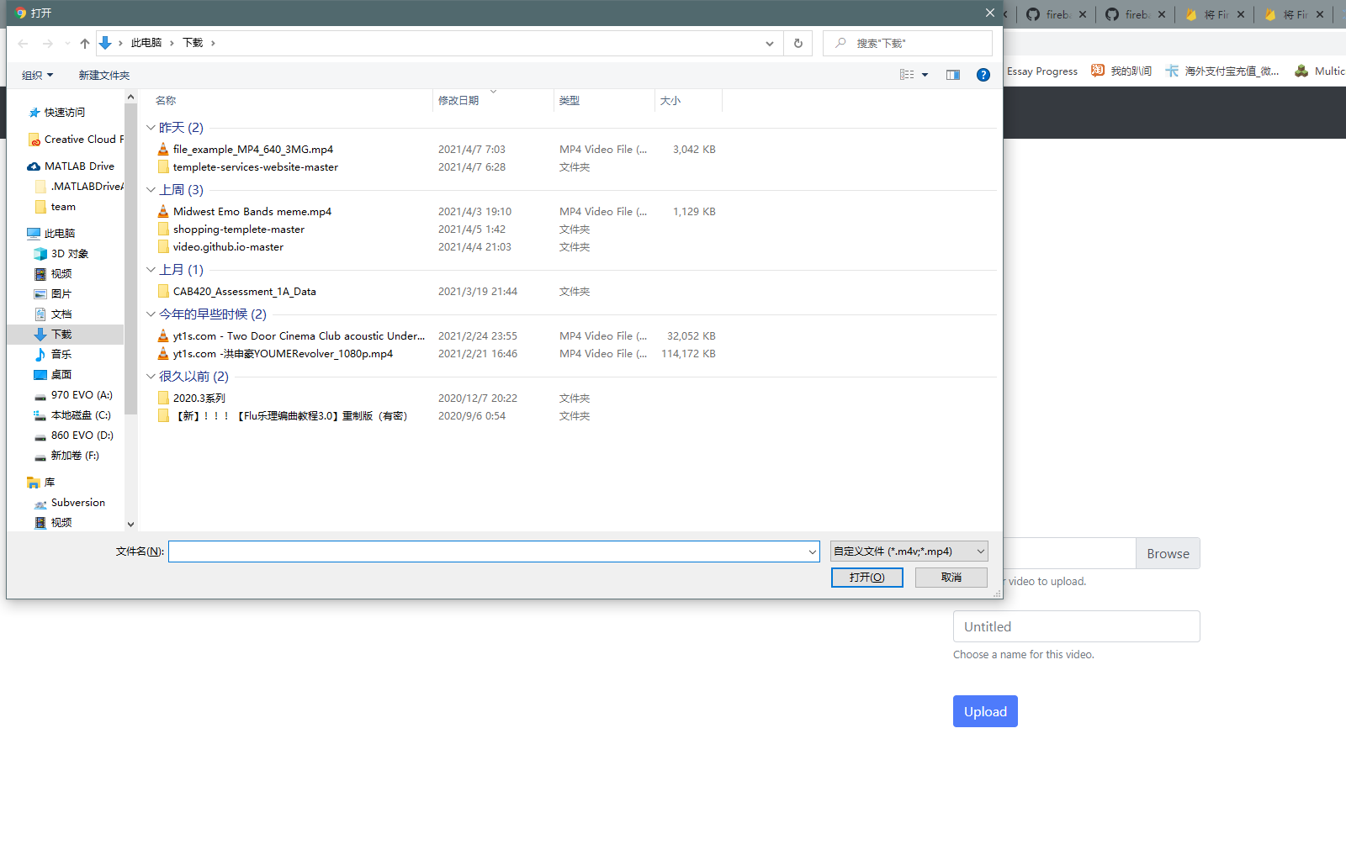

By implementing Cloudflare’s API, we can now upload video to the stream service in the webpage. Now i will choose a media file to upload, I can also name the media or use the default name ‘Untitled’.

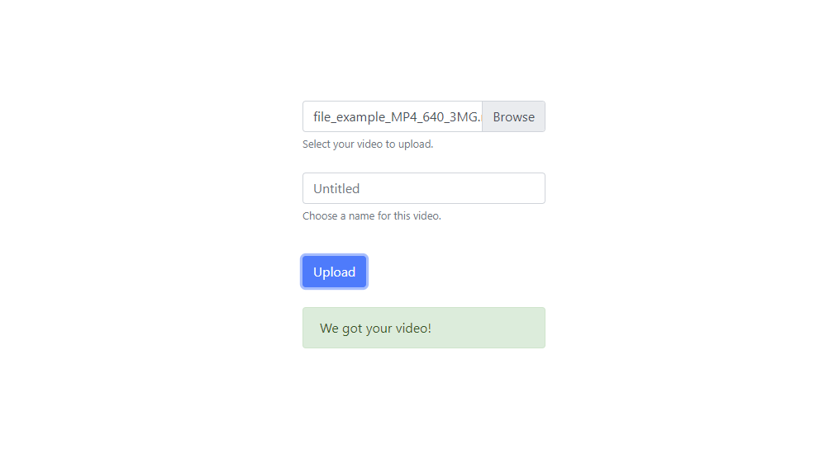

By pressing upload btn, the video will be uploaded and a feedback will be given to users.

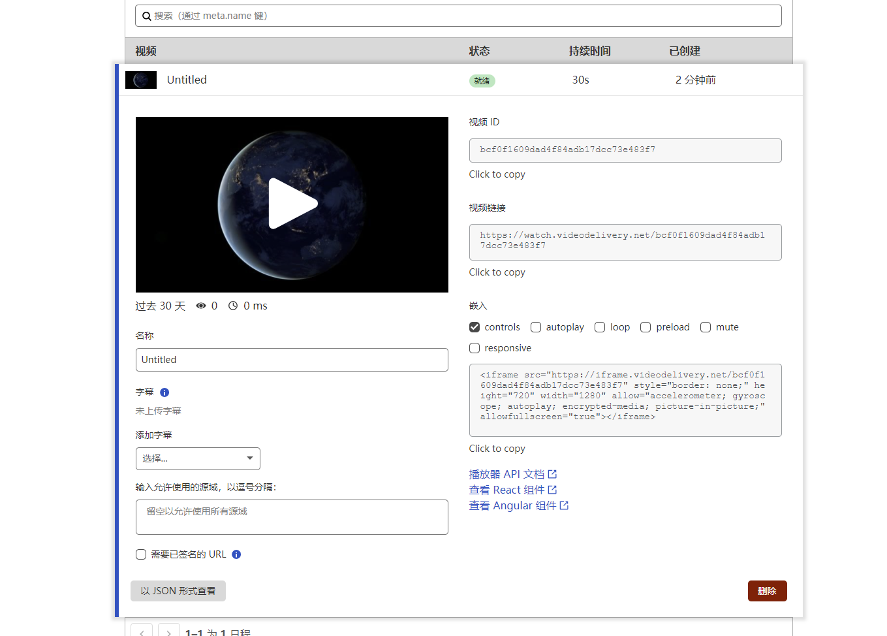

We can see the video is here in the cloudflare dashboard, the upload succeeded. Now I want to try to play this video in our application. I will copy the id and tell the player manually,

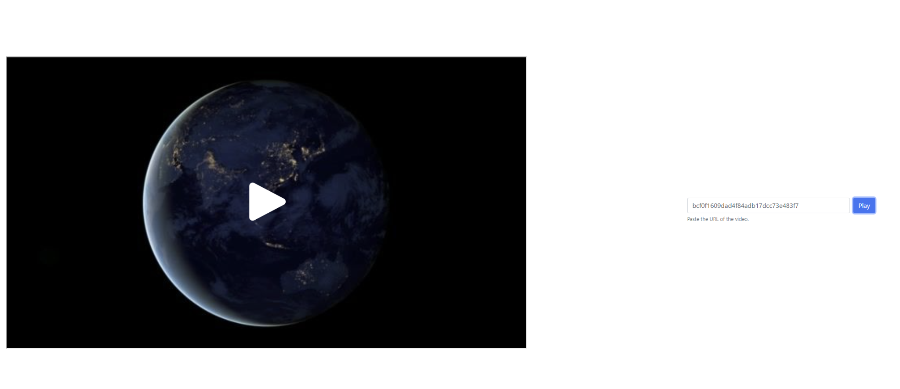

The video is now ready to play! We can also try a larger video with sound …. Note that all futures are built with error handling, users would also get the feedback if anything goes wrong.

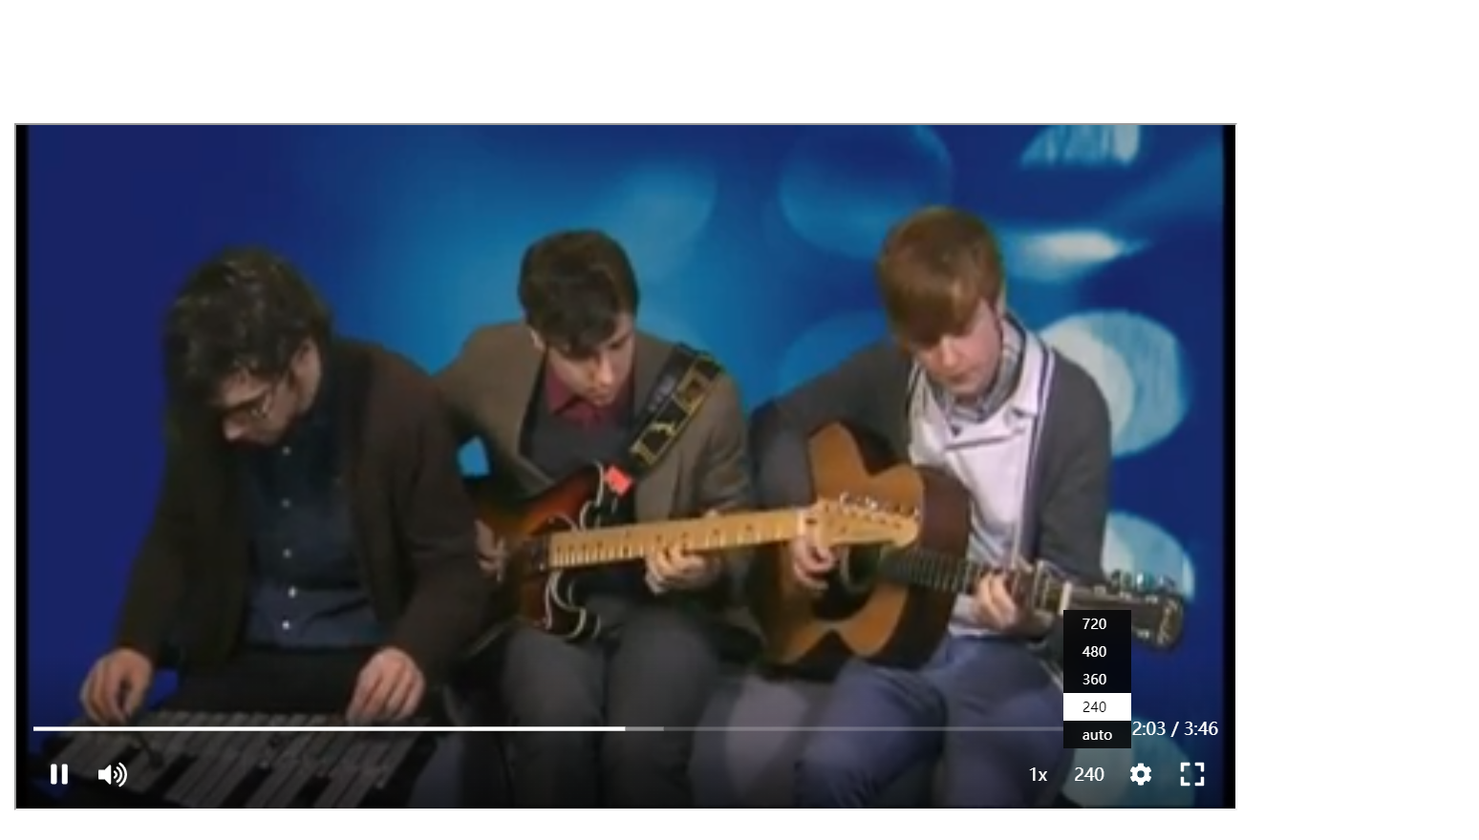

Thanks to Cloudflare’s api, we are also able to change the playback speed and resolution.

So that is our current progress on the frontend side,

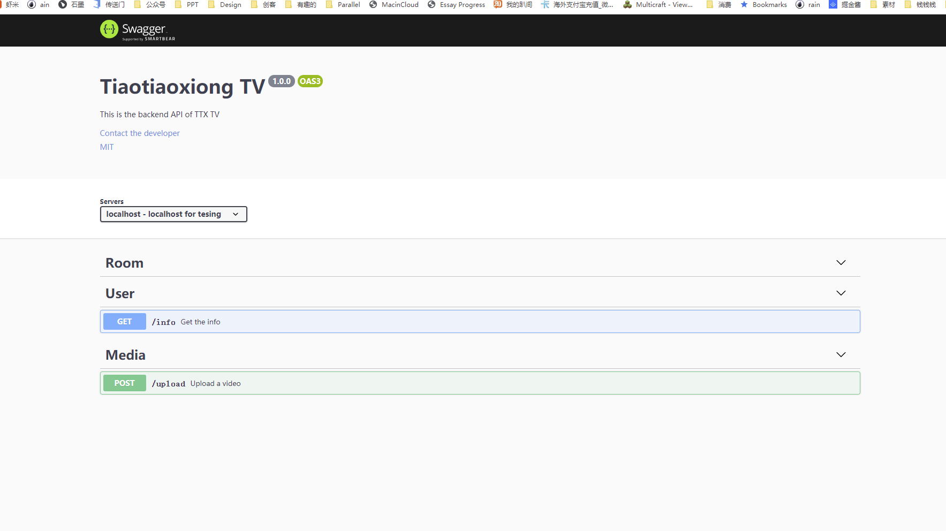

On the backend side we decide to serve the functions as a RESTFUL API, so that it could provide the front end a neat and normative access. We want this to be well designed and documented, current stage we are still working on the design . Now if i access the backend app, it will show me a swagger api document with very few interfaces.

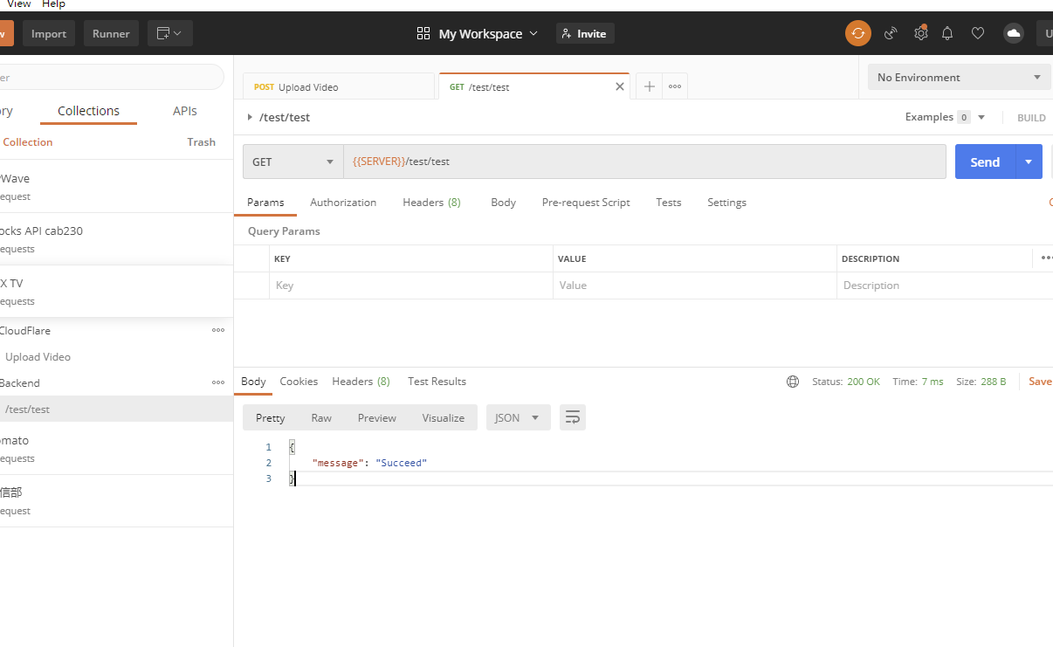

We can use this for testing, i will send a get request using postman, and it will return a message. Me and my partner will continue work on this and finish all the interfaces by next iteration.

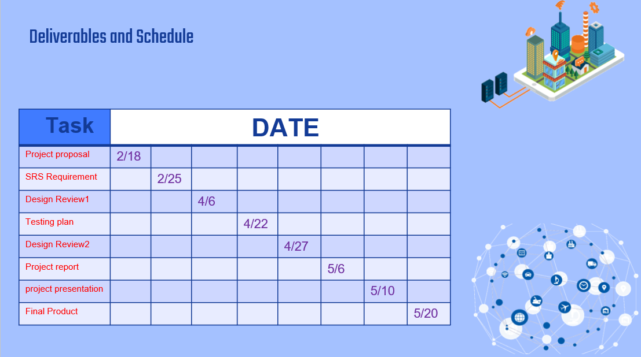

As you may see, there is still a lot of work to be done, but we are very positive about the progress. We will stick with the current plan, continue to complete the remaining works and start testing. Hopefully we will deliver our application on time. Thank you。